WHY WE NEED TO SUPPORT SUSTAINABLE ENERGY
18/12/2013

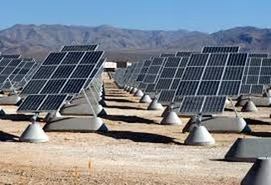
I am no climate scientist and I won’t even try to prove that Climate Change is real because, in the end it doesn't matter. What I hope to do is to show that we need to act now to promote energy sustainability even if Climate Change is being exaggerated.
For now, just assume that Climate Change has been proved so conclusively that even Nigel Lawson accepts it as a reality. If this is the case, then it would be madness not to try to exploit all possible sources of sustainable energy while shutting down the carbon based sources immediately. Even the biggest Climate Change denier would accept this; otherwise the planet will soon become uninhabitable.
On the other hand, now assume that Climate Change isn't happening and we could happily carry on using carbon based energy source with immunity. However there are two problems with this. Firstly, all these carbon-based sources are finite and in 50, possibly 100, years they will run out, meanwhile they will get more and more expensive. Secondly, burning carbon in one form or another is dirty and messy with a number of toxic emissions that need to be controlled and waste to be disposed of.
Would we not be better off developing a free (except of installation & transmission) energy source that is practically unlimited, has no toxic by-products or harmful waste to deal with? I won’t pretend that there isn't a lot of costly work to do, better ways of harnessing solar/wave/tidal/wind power needs to be developed, better ways to store energy have to be devised so that power generated but not used straight away can be stored, electric vehicles need to be improved so that they can run longer & re-charge quicker. It can’t happen overnight but with the right investment and will power it is possible.
Even if Climate Change has been exaggerated (which I personally doubt), we need to start supporting sustainable energy now otherwise we condemn ourselves to using dirty fuel that will slowly become scarcer and scarcer. It seems to be what the young today call a no-brainier, stick with a finite dirty energy source or move to a clean unlimited one?

