WHAT TO LEARN FROM NELSON MANDELA
06/12/2013

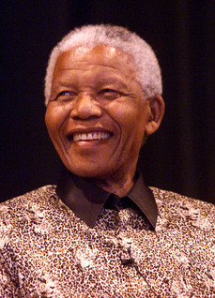
Yesterday a great man died. Even though Nelson Mandela’s passing had been expected for some months, when the moment came, I was still left with a feeling of sadness at our loss and respect for a man who showed that, by renouncing hate and embracing your enemy, it is possible to achieve what was seemingly impossible. I know many other have written about Mandela’s legacy, and probably have done it far better than me, but I feel moved to add these few words.
I remember that day back in February 1990 when I watched with anticipation Mandela’s release from 27 years imprisonment and how by his speeches and actions he, over the months and years that followed, managed to bring a country on the verge of a bloody civil war back from the edge to find its way to be, if not a paradise on earth, a country where the colour of one’s skin is not the most import part in determining your rights. You just need to look to the north of South Africa, to Zimbabwe, to see how such a transition from white oppression can be mishandled.
Mandela’s message of love, forgiveness & reconciliation is better than hate, grudges & letting grievances fester is just as relevant to us here in the UK today as it was in South Africa 25 years ago. I have been upset by some of the responses to Mandela’s death, not from those who have never been able to accept that Mandela was not the doctrinaire Communist Terrorist as he was portrayed by some in the West before his release, but by those on the left who professed support for him & his struggle but have used the occasion to launch attacks on people who have come to respect Mandela even though they once opposed him. This pettiness is not worthy of Mandela’s legacy and only shows that those who have indulged in these attacks as small-minded.
In 1964, Mandela finished his epic speech from the dock in the Rivona Trial with these words:
During my lifetime I have dedicated myself to this struggle of the African people. I have fought against white domination, and I have fought against black domination. I have cherished the ideal of a democratic and free society in which all persons live together in harmony and with equal opportunities.
It is an ideal which I hope to live for and to achieve. But if needs be, it is an ideal for which I am prepared to die. (http://www.rfksafilm.org/html/speeches/mandela.php)
These are words I can subscribe to wholeheartedly and I only hope I can live up to them as bravely and as successfully as Nelson Mandela did.
We have lost a great man and an example to us all, may he rest in peace,

